

How to run a

SOFIE Club








Published by SOFIE
© 2009 Institute of Education, University of London

SOFIE is a three year Research Project supported by the UK Department for International Development (DFID) and the Economic and Social Science Research Council (ESRC). Its purpose is to strengthen open, distance and flexible learning (ODFL) systems and structures to increase access to education for young people living in high HIV prevalence areas in Malawi and Lesotho. It seeks to achieve this through developing a new, more flexible model of education that uses ODFL to complement and enrich conventional schooling. It also seeks to encourage application of the new knowledge generated through effective communication to development agencies, governments, development professionals, non-governmental organisations and other interested stakeholders.
Access to education and learning is being viewed as a ‘social vaccine’ for HIV but in high prevalence areas orphans and other vulnerable children are frequently unable to go to school regularly and are thus being deprived of the very thing they need to help protect themselves from infection. In this context sustained access is critical to long term improvements in risk and vulnerability and it requires new models of education to be developed and tested.
The partners
The research team is led from the Department of Education and International Development, Institute of Education, University of London and the research is being developed collaboratively with partners in sub-Saharan Africa.
Lead partner
The Department of Education and International Development, Institute of Education, University of London:
Dr. Pat Pridmore and Mr. Chris Yates
Collaborating partners
The Institute of Education, National University of Lesotho: Dr. Thabiso Nyabanyaba.
Centre for Education Research and Training (CERT), University of Malawi: Ms. Catherine M Moleni
The South African Institute for Distance Education (SAIDE): Ms. Tessa Welch and Mr. Ephraim Mhlanga

SOFIE
Department of Education and International Development
Institute of Education
20 Bedford Way
London
WC1H OAL
United Kingdom
Tel: + 44 (0) 20 7612 6152
Website: www.ioe.ac.uk/sofie
Email: m.harri@ioe.ac.uk

Welcome to the SOFIE Project
The SOFIE project aims to support the learning of vulnerable pupils who may be ’at risk’ of dropping out of school or repeating the grade.

This guide explains your role as the leader of the SOFIE Club and also the roles of the other members who will be working with you to support the learning and wellbeing of the club members.

Contents
- Your role 3
- Getting started 4
- At the first SOFIE Club Meeting 4
- Organising fun games and activities 5
- Helping with Maths and English 7
- Listening and offering support and encouragement 8
- Building a circle of support around the learner 9
- Roles 9
Annex 1 Sample session plan for the SOFIE club 12
Annex 2 For your own notes 13

1. Your role

Pupils who are at risk of falling behind with their school work or dropping out of school because they cannot attend regularly will be invited by their class teacher to attend a SOFIE Club for two or three hours each week where they can have some fun and get support with learning Maths and English.

Your role as the SOFIE Club Leader is to set up this Club and run it each week until the end of the current school year.

You will need to:
- Be responsible for keeping the contents of the School-in-a Box safe and secure.
- Plan and organise weekly clubs at a time suitable for the pupils. (A sample club session is found at the back of this Guide, but it is important that you also get suggestions from pupils on how they would like their club to be run.)
- Use the materials in the School-in-a-Box to organise games and other activities so the pupils can have fun and get support for learning.
- Help pupils with the Maths and English tasks in the study guides and any set by the class teacher, so that they can keep up with their school work.
- Listen actively to their problems and concerns and offer support and encouragement for their lives.
- Keep in touch with the class teacher to make sure all the pupils on his/her ‘at risk' register have been invited to come to the SOFIE Club, and that the teacher checks their completed Maths and English tasks every two weeks and sets new ones.
- Visit children at home who do not attend regularly, offer support for their learning and encourage them to come to the SOFIE Club.
- Keep in touch with the members of the school management committee (SMC) who will also be trying to support the ‘at risk’ children in their lives.
- Keep a ‘diary’ of club activities and report to the SOFIE committee on the progress of the Club.
The class teacher will give each ‘at risk’ pupil a class ’buddy’ to be their friend. The buddy will be invited to come along to the SOFIE Club with their partner. The buddies will join in the games and help their partners do the Maths and English tasks. The buddies will also make sure that the pupil (or their buddy) takes the completed Maths and English tasks back to school every two weeks so that the class teacher can check their progress.

Getting started

- Find a quiet, central place where you can hold the SOFIE Club for two or three hours each week, at time suitable for the pupils. This might be at the bwalo, a church building or even the school. It should be somewhere where the pupils will feel comfortable. You might have to get permission from community leaders. The SMC can assist you in this.
- Introduce yourself to the class teacher and collect the list of ‘at risk’ pupils. Confirm that the teacher will tell these pupils the time and place where the Club will meet and invite their class buddy to come along with them. (The teacher might add more pupils to this list during the year and you will need to get these names also.)
- Confirm that the class teacher has given each ‘at risk’ pupil a School-in-a-Bag containing text books and study guides for Maths and English, some notebooks and pens.
- Collect your ‘School-in-a-Box’ from the class teacher and check the contents. The box should contain a ‘Choices and Decisions’ board game, a set of Maths and English textbooks and learner guides, supplementary readers and file folder and pens for you use.
- Discuss how the class teacher will check on the progress of the pupils. The teacher will need to see the study guides every two weeks to check that tasks in the guides have been done satisfactorily. The teacher may also set additional tasks in Maths and English to make sure that pupils have really understood what they have learned in the study guides and are keeping up with their fellow pupils.

At the first SOFIE Club Meeting

- Before the meeting try to visit the pupils who are on the ‘at risk’ list given to you by the class teacher and invite them to come to the Club.
- At the Club greet the pupils and their class buddies as they arrive and start forming a good relationship with them from the start. Talk about something that it is easy for them to discuss with you. For example, find out about their interests, such as sports or music, and ask them about their likes and dislikes. As you talk together they can get to know you and decide whether they are comfortable with you.
- Play some ‘icebreaking’ games – examples are given in the next section.
- Explain that each Club meeting will start and end with games and also do some Maths and English tasks. Ask them to suggest games that they like to play and other activities that you may be able to organise. You will find a sample plan for a session at the end of this guide.
- Make sure that pupils are comfortable with the choice of venue and time of the meeting and discuss any arrangements for the next Club meeting. Remember you can also ways change the time and/or venue to fit the pupils’ needs.
- After the Club go to visit any pupils on the ‘at risk’ list who do not come to the Club and encourage them to attend. If any of these pupils still do not come, get in touch with the class teacher and a member of the SMC to discuss what can be done to help him/her.

4. Organising fun games and activities
It is important that the SOFIE Club starts and ends with some fun games to encourage pupils to come and enjoy themselves. The football, and ’Choices and Decisions’ game in the School-in-the–Box will help you, but be sure to include some games in each session that have been suggested by the children.

- The football
You can organise football, netball and other ball games that the pupils like to play. Make sure that both boys and girls have opportunities to use the football. Remember, other pupils at the school may also wish to use the football – this is okay, as long as it is not at the same time as the Club meeting. Discuss how you can share the football with the school head or class teacher.
- The ‘Choices and Decisions’ game.
‘Choices & Decisions’ is a board game that has been designed to equip young people in Malawi with life skills, knowledge and confidence to take responsibility for their own actions and lives. It is a fun way of learning about sexual reproductive health (SRH), gender and HIV and AIDS and can help young people improve their self-esteem through interacting with their peers. The game can be played with 6 to 8 people, but if there are more in your club you can organise them in teams. It takes between 30 minutes to an hour to play (sometimes longer). It might be a useful way to end a club meeting. You will receive training on how to facilitate this game.
- Using a radio
All schools should have at least one radio. Discuss with the school head or the class teacher how you might share the radio. If you are given permission to use it, you can play music during the club meetings and to listen with the club members to programmes. Start by asking pupils what programmes they like to listen to and try to include some programmes in English and some ’edutainment’ programmes that are a fun way of learning about relationships and other things that are useful in their lives.

Ideas for Icebreaker games

Name game: Everyone should stand in a circle- go round the circle and shout out a name. Throw the ball to someone across the circle and the name of the person you are throwing the ball to. Members of the group should continue to pass the ball around the circle quickly, shouting out the name of the person it has to be passed to. Once in a while shout out ‘Change’, then change direction of the ball.

Name game (2): This one is quieter! When first introducing ourselves, each member of the group should use an adjective starting with the same letter as our first name (e.g. Troublesome Ted, Sweet Sarah, Jolly John!).

Human knot: Everyone stands in a small circle facing each other. Everyone sticks their hands into the centre of the circle and randomly clasps someone else's hand with each of their own hands. (Each person should be holding hands with two others). The objective of the game is to untangle this "human knot" without anyone letting go of a hand, ending up with one large circle (although sometimes, two separate or linked circles might be the end result). The participants have to step over or under each others linked arms, with the close
physical proximity and silly maneuvers breaking the ice between strangers. This game also requires team work and decent leadership skills in one or more participants.

Sinking Ship: Everyone stands in a circle facing each other. The facilitator explains that they are all on a ship that is in danger of sinking. The facilitator tells everyone to start walking around looking for the lifeboats. S/he will then call out a number (2, 3, 5 etc.) and everyone has to form groups of that number in order to enter the lifeboats! The idea is that people should do this as quickly as possible! Anyone who is not in a group will be drowned and has to leave the game. Then the facilitator starts the process again, this time calling out a different number. You can continue as many times as you like. N.B. This is also a fun way of dividing people into groups for group work!

Why....Because? This is a simple, silly ice-breaker that can be done in a quiet moment. You will need small pieces of paper and writing materials. Divide the group into two smaller groups of equal size. In the first group, ask everyone to write a simple question beginning with ’Why..?’ It does not have to be very serious (e.g. ’Why did you come here today?’ or ’Why did you eat rice for lunch?’). In the second group, ask everyone to write a simple statement beginning with ’Because..’. Again, it can be anything they think of. (e.g. ’Because it was raining’ or ’Because the goats got into the garden’ or ’Because I was bored’). Then the facilitator should pick one person at random from the first group to read out their question, then one person from the second group to read out their answer. You can get some very funny matches!!

Autographs: Prepare a sheet of paper with 10 squares on it. In each square write 1 statement like ‘likes the colour red’, ‘has travelled outside Malawi’ or ‘has eaten fish today’, for example. All the members should also prepare (or be given) a sheet with the same statements on it. Then ask the group members to go and ask other members of the group to sign the sheet if the statement applies to them (i.e. to collect their autograph). Keep going until they have filled in all the squares.

Line up! Ask all the members to line up from the tallest to shortest without talking. OR, ask all members to order themselves according to the colours of the rainbow (according to clothes they are wearing). You can adapt this game using different ideas…..e.g. alphabetical order, age etc. What makes it difficult is that they have to do it without talking!!

Other Activities

Discuss with the pupils what other activities they might want to include during their time at the clubs.

For example:
- Practising traditional dances
- Sharing and teaching other members songs that they may know (starting a choir?)
- Performing role plays or dramas (there are lots of examples of simple role plays, poems etc. in the pupil textbooks. The pupils could practise these or come up with their own ideas).
- Debating topics they have read about in supplementary readers or newspapers or heard on the radio. (if you are doing this you should avoid debating politics or religion, to avoid offending somebody – good topics would be: health-related, behaviour change, the importance of education, supporting your community, human rights, child labour, gender etc.)
- ‘Press conference’ – a few pupils should find out more about a local topic of interest in your community (e.g. opening of a new pre-school or CBO, a wedding or other cultural event) and hold a press conference, inviting other club members to be the ‘journalists’ and ask them questions.
- Competitions – how good are your club members at playing bawo? Perhaps you could divide the club members into pairs and organise a competition (N.B. if you don’t have bawo boards, then you can simply make holes in the earth and use small stones/beans!).

5. Helping with Maths and English

- Remind each ‘at-risk’ student to bring their School-in-a-bag with them to the SOFIE club every week with the textbooks, study guides, notebooks and pens. (Their class buddy can help them remember.)
- Help them to find the next Maths and English tasks that they shuold be working on and any additional tasks set by the class teacher and (if they have not already done it) ask them to do it now. (Their class buddy can help them, and you can help them, but they must do the task themselves.)
- If the class teacher is not and checking the pupils’ progress and giving them Maths and English tasks, then go to visit the teacher to request that he/she does this. If there are still no tasks set then help the student to work their way through the units in the study guides. (There are additional copies of the study guides and text books in your School-in-a-Bag.)

6. Listening and offering support and encouragement

- Vulnerable pupils often have many worries and challenges in their lives and may not have any adult to talk to about them at home.
- Drawing, storytelling and drama or role-play can be good ways for young people to raise issues they want to communicate with others but find difficult to discuss directly. The methods, language and information used should be appropriate to the pupil(s) age and developemental level.
- Listen to and supporting vulnerable pupils can be challenging and highly emotional. You need to be aware of your own personal attitudes, opinions and reactions to the cultural, traditional and gender attitudes that influence the experiences of these young people and not let them affect the quality of the support you give them.
- You also need to be aware of which attitudes it would or would not be appropriate to raise or challenge. Be very careful not to impose your own religious or cultural beliefs. These may not be the same as the pupils’ and may make them feel confused and pressured.
- You need to reassure the pupil that things discussed will be kept confidential. However, you will also have too explain that this might be broken if there are life-threatening situations concerning the child’s physical welfare. In such a case a responsible adult, such as a social welfare officer or police officer will have to be contacted
- Here are some hints and tips to help you listen actively to the pupils.
- You will learn more about how to support the emotional needs of the pupils during your training.

DO
- Build a friendly and trusting relationship with the student.
- Listen attentively and help (but never force) them to tell their story.
- Give correct and appropriate information and help them make decisions.
- Help them recognise and build on their strengths and encourage them to have positive attitude to life.
DO NOT
- Judge them or blame them.
- Make decisions on their behalf.
- Interrogate them, preach or lecture to them.
- Make promises you cannot keep.
- Impose your own beliefs on them.
- Argue with them.
- Have sexual relationships with students.



7. Building a circle of support around the pupil

- At the start of this guide we explained that the SOFIE Project aims to support the learning of vulnerable pupils who may be ’at risk’ of dropping out of school or repeating the grade. To achieve this aim the Project is working with schools to build a circle of support around each ’at risk’ student.
- The circle of support involves you working with the student, the class teacher, the class buddy and the SMC members to support the student’s learning as shown in the diagram below.

Diagram to show the circle of support around the student
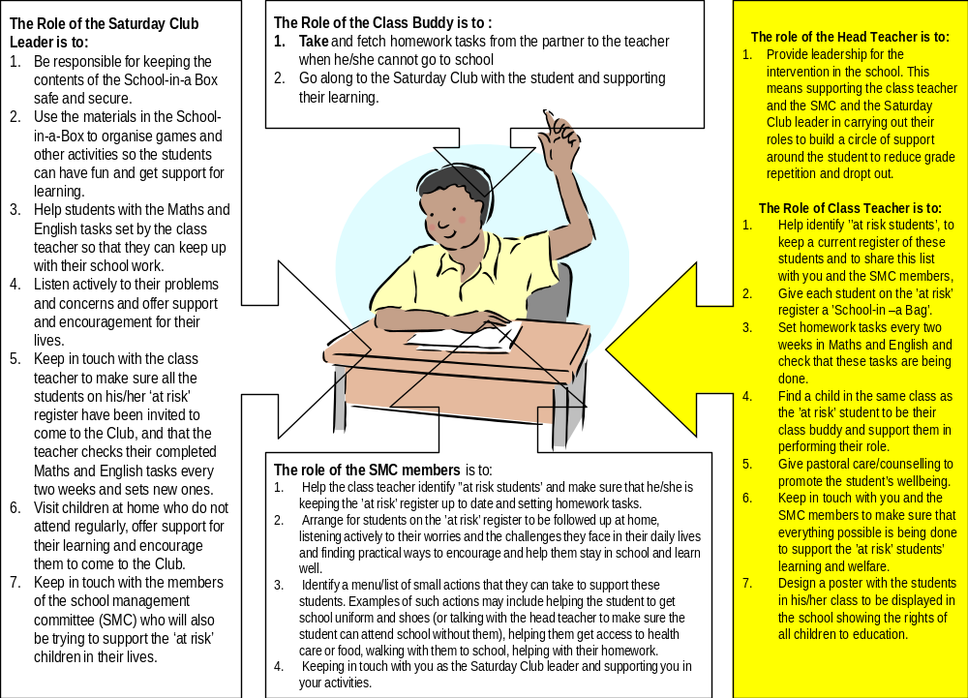

8. Roles

- Your role as the SOFIE Club Leader has been explained above.

- The role of the class teacher in the school is to:
- Help identify ’at risk pupils’, to share this list with you and the SMC members and to keep the ’at-risk’ register up-to-date.
- Give each pupil on the ’at risk’ register a ’School-in –a Bag’.
- Check the progress of the ’at-risk’ pupils every two weeks as they work through the Maths and English study guides. Set additional homework tasks in Maths and English as appropriate and check that these tasks are being done.
- Find a child in the same class as the ’at risk’ pupil to be their class buddy and support the chosen buddy in performing their role. It is best to choose a buddy who is friends with the ’at risk’ pupil, lives near to them, attends school regularly and is able to help them with their schoolwork.
- Give pastoral care/counselling to promote the pupil’s wellbeing.
- Keep in touch with you and the SMC members to make sure that everything possible is being done to support the ’at risk’ pupils’ learning and welfare.
- Design a poster with the pupils in his/her class to be displayed in the school showing the rights of all children to education.

- The role of the class buddy is to:
support the learning of their ’at risk’ partner by...
- Taking and fetching Maths and English tasks for checking from the partner to the teacher when s/he cannot go to school
- Going along to the SOFIE Club with their partner and supporting their learning.

- The role of the SMC members is to:
- Help the class teacher identify ’at risk pupils’ and make sure that he/she is keeping the ’at risk’ register up to date and ecking pupils’ progress and setting additional Maths and English tasks.
- Arrange for pupils on the ’at risk’ register to be followed up at home, listen to their worries and the challenges they face in their daily lives and finding practical ways to encourage and help them stay in school and learn well. They can also suggest that the pupil talks about their worries and challenges to their class teacher.
- Identify a menu/list of small actions that they can take to support these pupils. Examples of such actions may include helping the student to get school uniform and shoes (or talking with the head teacher to make sure the student can attend school without them), helping them get access to health care or food, escorting them to school, helping with their homework.
- Keep in touch with the SOFIE Club leader and supporting you in your activities.
- Liaise with class teacher to ensure safe-keeping of any SOFIE materials that have not been distributed to ’at-risk’ pupils.
- Help to sensitise the community on the SOFIE Project.

- The role of the head teacher is to:
  - Provide leadership for the intervention in the school. This means supporting the class teacher and the SMC and the SOFIE Club leader in carrying out their roles to build a circle of support around the pupil.
  - Alongside the SMC, sensitise the community on the progress of the SOFIE Project (this might include briefing village-based committees, such as the Village Development Committee and/or holding open days).
  - Support monitoring of pupils by checking that attendance registers (including ’at-risk’ registers) are being filled in on a daily basis and liasing with SMC to ensure that absent pupils are followed up.
  - Brief the PEA during his/her visits on any issues arising from the SOFIE project.

N.B. Activities of the SOFIE project are likely to be coordinated by a committee. This committee can be responsible for supporting and monitoring SOFIE activities. For example: following up on ’at-risk’ pupils, sensitising the community and being responsible for safe storage of SOFIE materials. Suggested members for this SOFIE committee are:
    - School head
    - SMC member (male)
    - SMC member (female)
    - Class teacher (standard 6)
    - CBO representative or extension worker
    - Community leader
    - Club leader

As a SOFIE Club leader you will need to report regularly to this committee.

Good Luck!

Annex 1 Sample Session plan for the SOFIE Club

Before the start | Friendly time - greet pupils as they arrive and talk informally to them or organise a game of football/netball or dance/song while waiting for others.
Introductions  10 mins | Open with a prayer if you feel this is appropriate.  Start with traditional greetings and ask each pupil to tell the group one good thing that happened to them this week. Tell them one good thing that happened to you.
Activity 1  10 mins | Organise the pupils to play an ice-breaker game, dance or song
Activity 2  30 mins | Ask pupils to get out their English text books and work on any tasks set by their class teacher. Ask the class buddies to help their partner with these tasks, if necessary. Go round and give help to any child that needs it to complete the tasks. If a pupil has completed the tasks set by the teacher or has not had any tasks set by the teacher then help him/her to continue working through the study guide from where they left off last time.
Activity 3  10 mns | Organise the pupils to play an ice-breaker game, dance or song
Activity 4  30 mins | Ask pupils to get out their Maths text books and work on any tasks set by their class teacher. Ask the class buddies to help their partner with these tasks. Go round and give help to any child that needs it to complete the tasks. If a pupil has completed the tasks set by the teacher or has not had any tasks set by the teacher then help him/her to continue working through the study guide from where they left off last time.
Activity 5  45 mins – 1 hour | Play ’Choices and Decisions’ and discuss any issues arising from this.  OR  Give pupils time to read through supplementary readers on their own.  OR  Choose a topic from the supplementary readers, newspapers, radio and discuss as a group.  OR  Play a sports game or organise another fun activity
Closing | Close the session. Say a closing prayer if you wish.  Remind pupils of the time and venue of the next Club session.

Annex 2 For your own notes

SOFIE
Department of Education and International Development
Institute of Education
20 Bedford Way
London WC1H OAL
United Kingdom
Tel: + 44 (0) 20 7612 6152
Email: m.harri@ioe.ac.uk
Website: www.ioe.ac.uk/sofie

